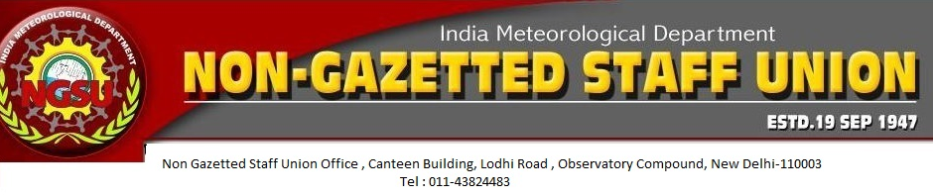

|  |
| --- |
| Ref No. :- NGSU/2/15 Date :- 20/07/2015 |

**CIRCULAR**

**Subject:- Election of New Central Executive Committee of NGSU.**

It is to state that as resolved in Union Council meeting held at Conference Hall, New Delhi from 13/07/2014 to 14/07/2014, the new CEC of NGSU is elected unanimously. The tenure of the CEC shall be for two years period i.e. 2014-2016. The following are the office-bearers of the new CEC.

1. Shri Pramod G. Sawant, Chairman
2. Shri Kunwar Singh , President
3. Shri Sanjiv Kumar Tyagi, General Secretary
4. Shri Raju Bhargav, Vice-President
5. Shri Gautam Roychoudhury, Asst. General Secretary
6. Shri A. S. Tripathi, Asst. General Secretary
7. Shri Rupesh Pandita, Treasurer
8. Shri Rohatas, CEC Member
9. Shri T. R. Mandal, CEC Member
10. Shri Vijay Pal, CEC Member.

Shri Vimal Raina, S.A. has been nominated as the auditor of CEC NGSU for 2014-2016

This is for information. 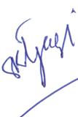

                                                                                                              (Sanjiv Kumar Tyagi)

General Secretary,

   IMD-NGSU,New Delhi